1. Create an Organization, Name it: Org_<YourLastName>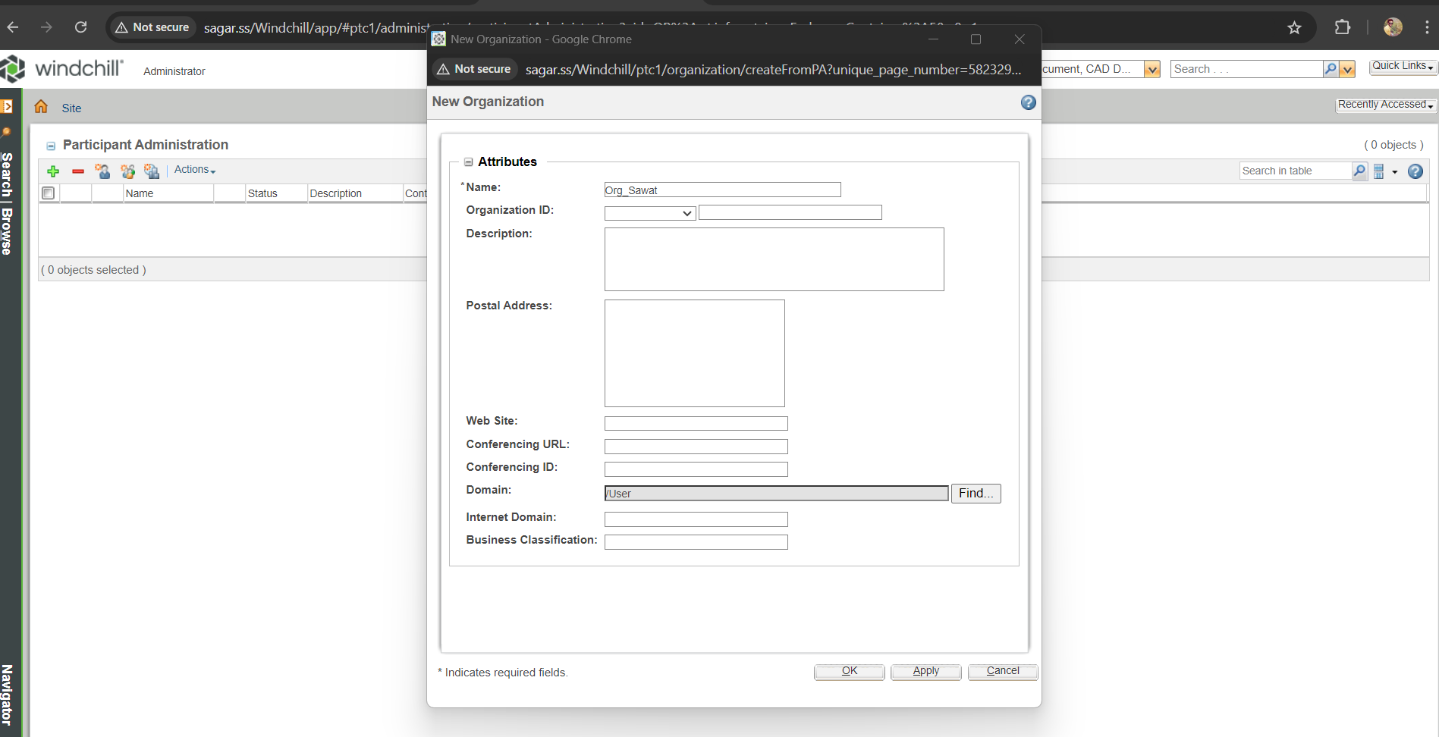

2. Create a user --> <YourLastName>_orgadmin

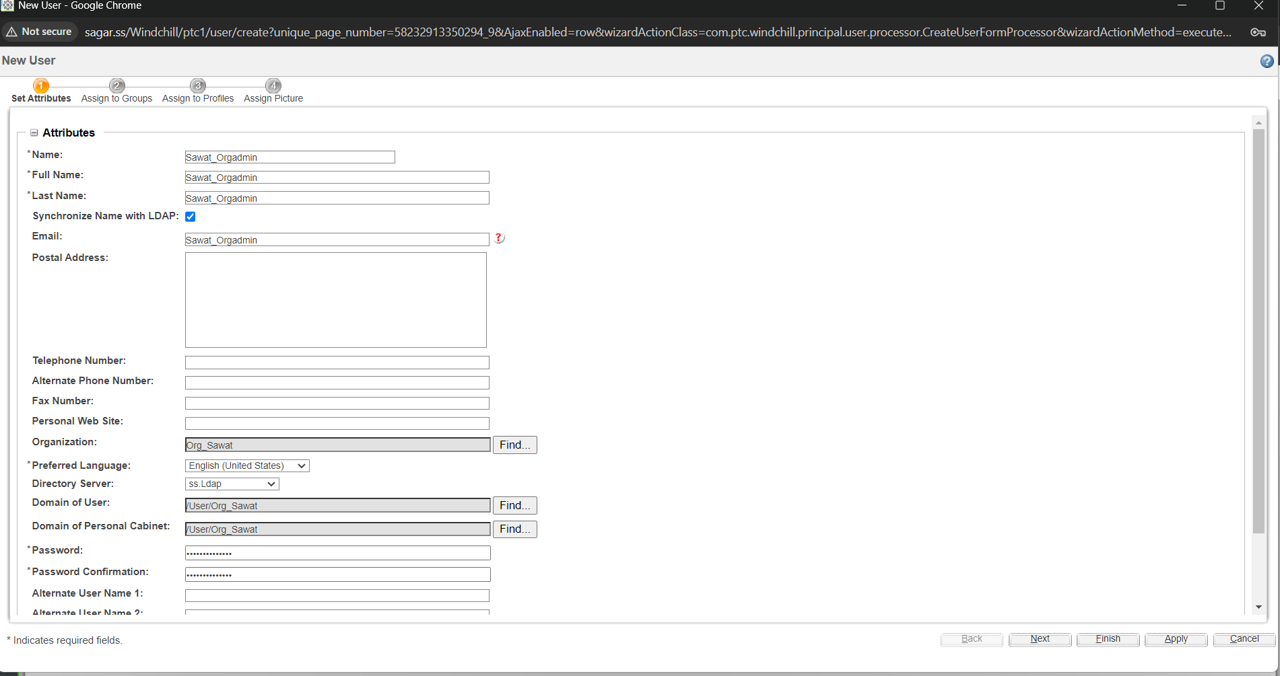

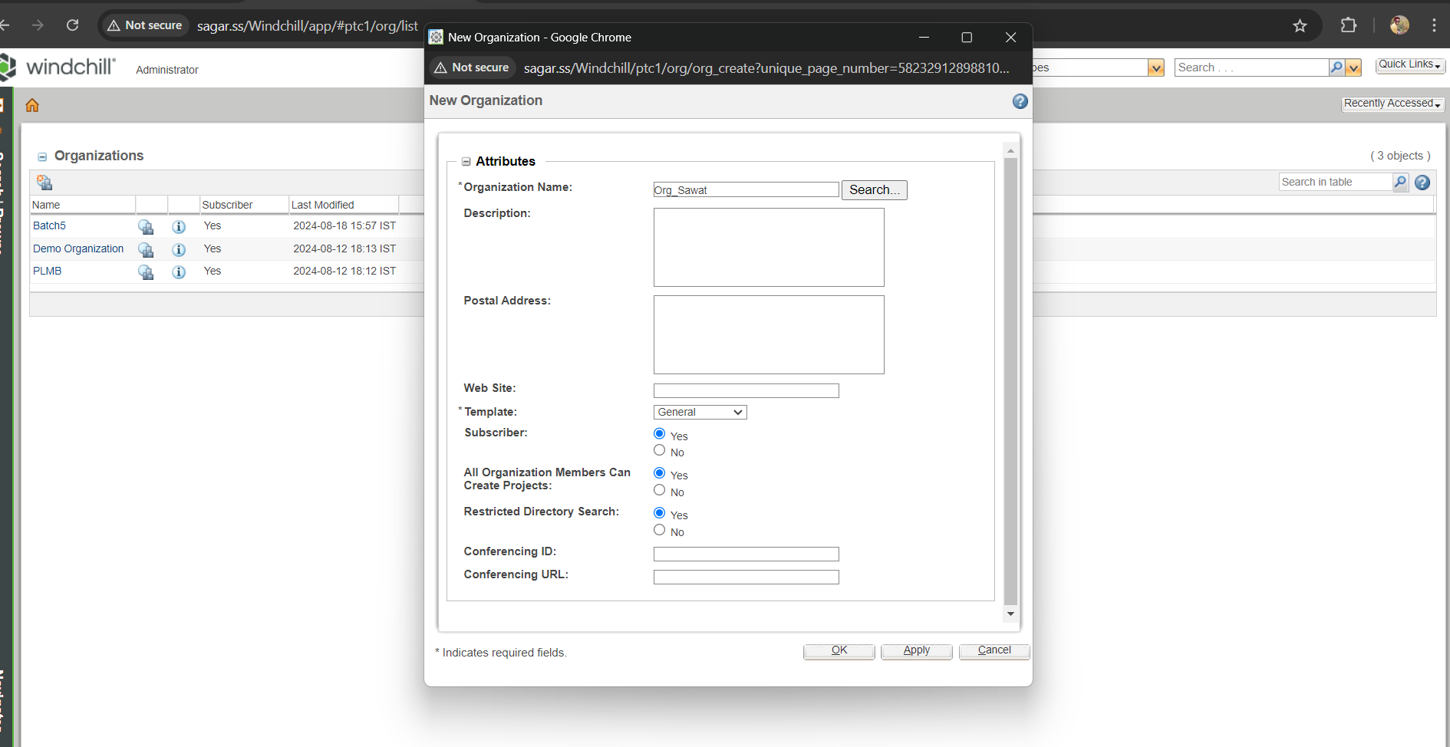

3. Make user: <YourLastName>_orgadmin as Organization Admin for the org you created in step 1

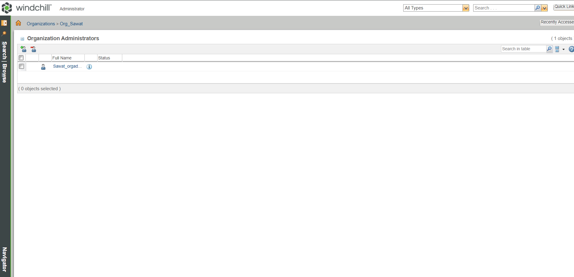

4. Login with <YourLastName>_orgadmin, make sure that user can access Organization link

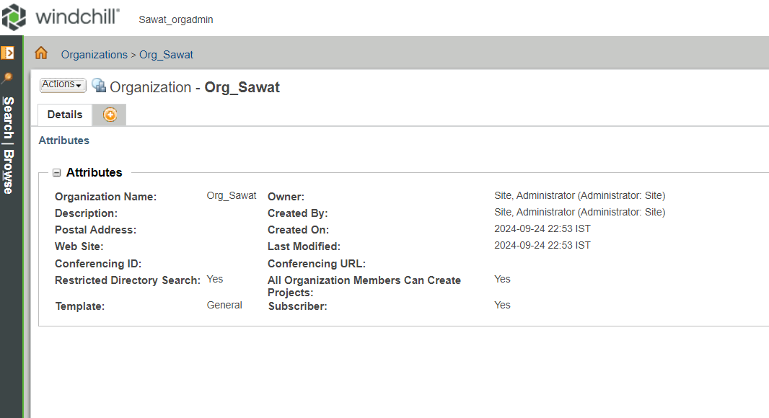

5. Create two users in Org_<YourLastName>, name it: product_user001, library_user001, allcreator001

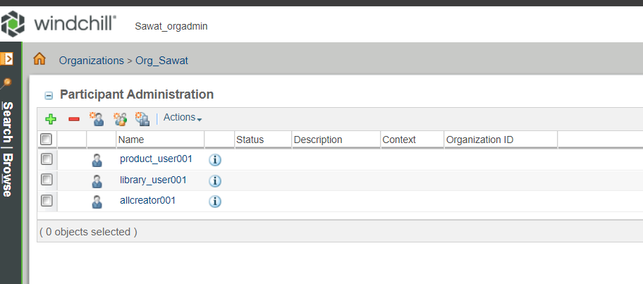

6. Make product_user001 as a product creator only, also add allcreator001 in product creator

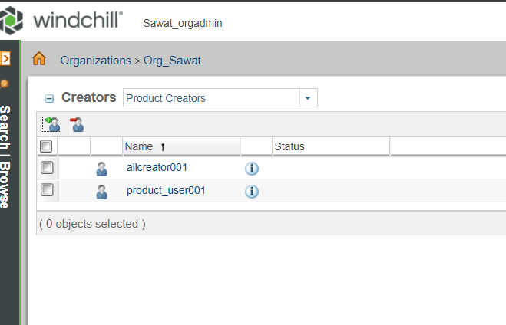

7. Make library_user001 as a library creator only, also add allcreator001 in library creator

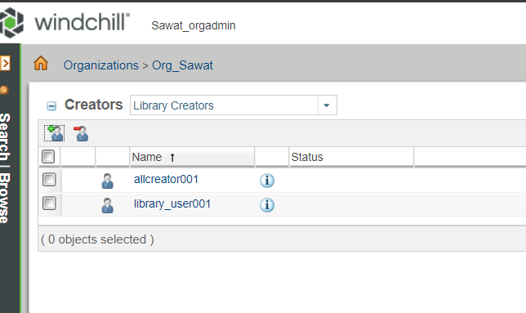

8. Login with product_user001 and create a product --> product001

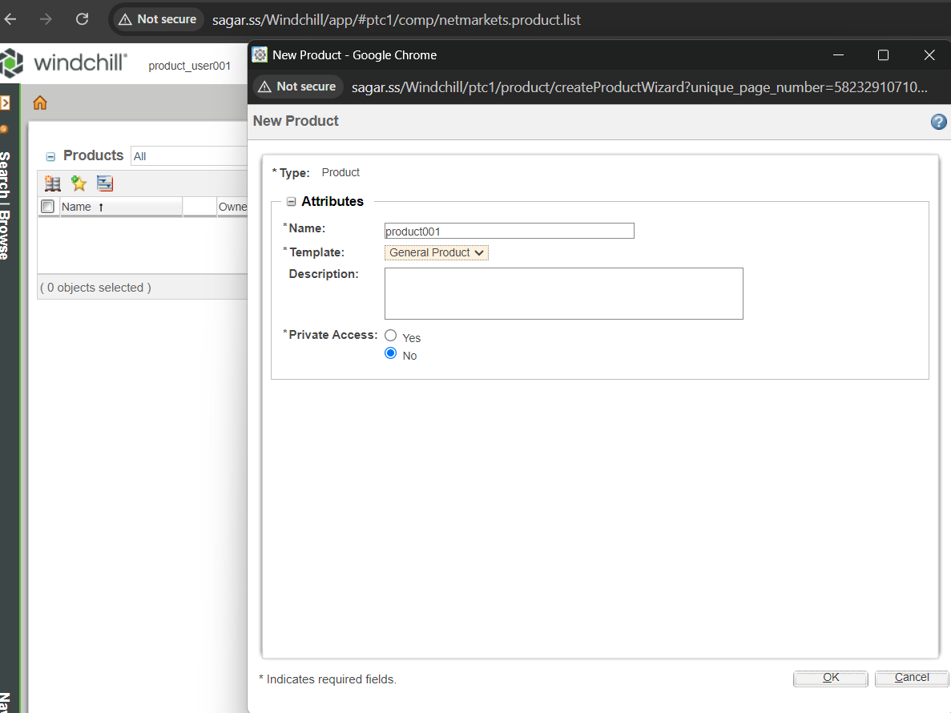

9. Login with library_user001 and create a library --> library001

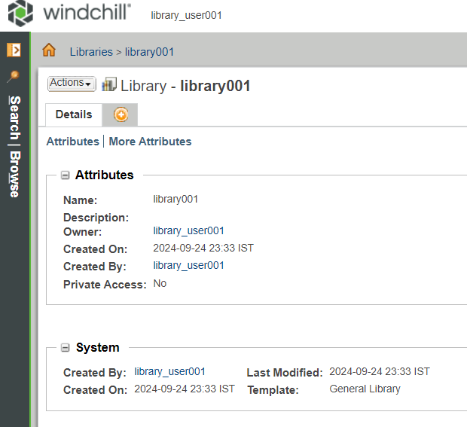

10. Create two more users(u001,u002)

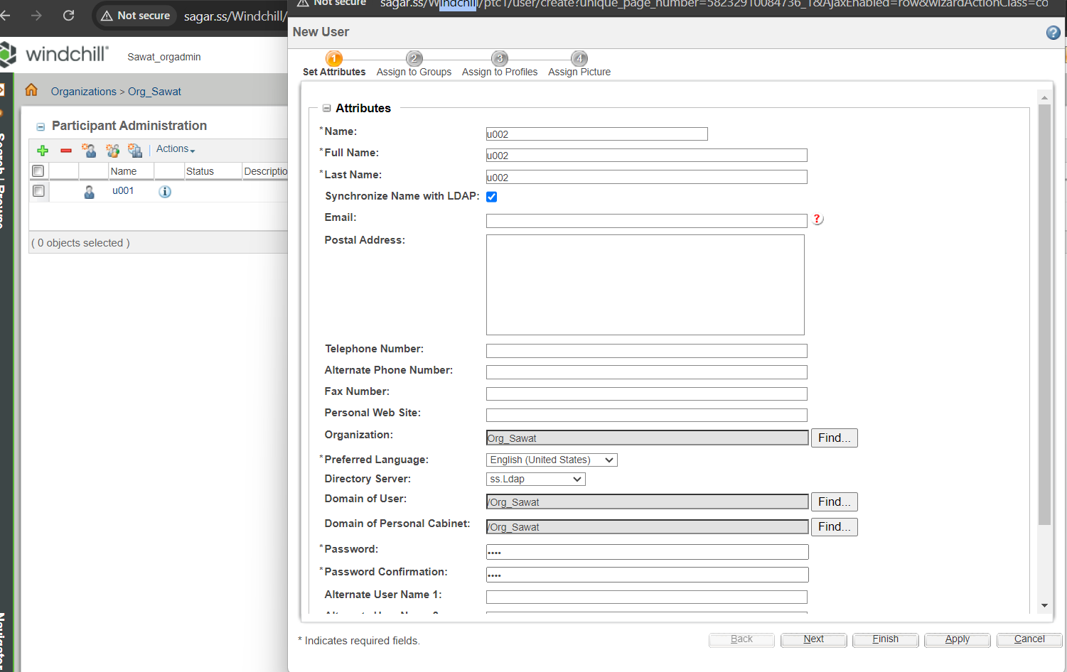

11. make u001 as member of product001

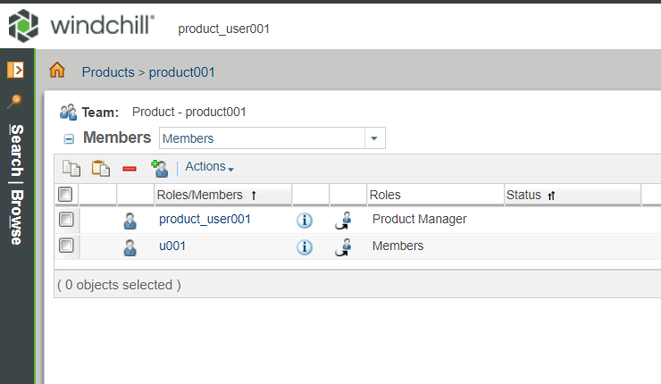

12. make u002 as member of library001

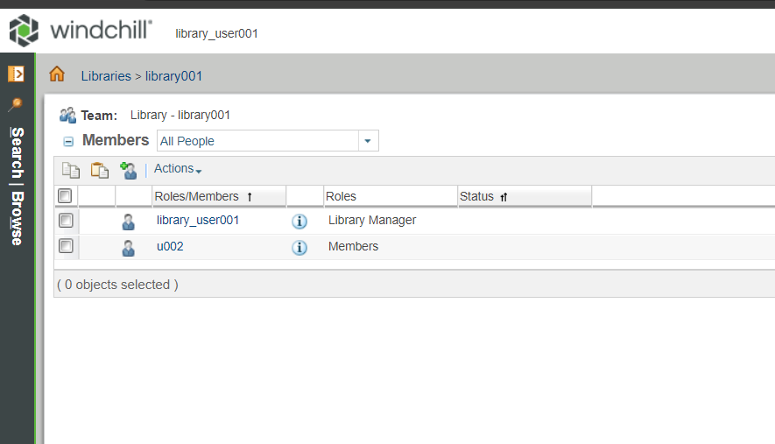

13. Login as allcreator001 and ensure if he is able to create both prod and library

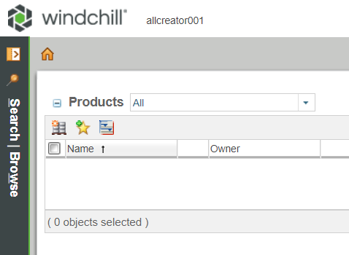

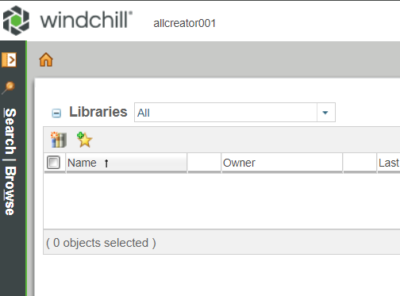

14. See what access u001 and u002



